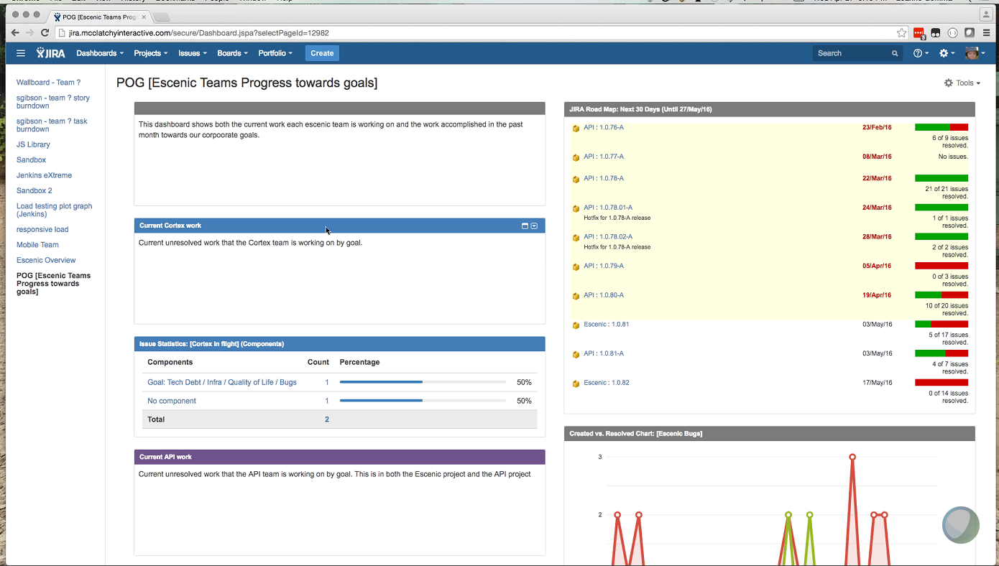

**Jira & Confluence**

* Test instance of Jira – integration with Sharewell tool for data flow
* Different projects in Jira, mapped to code respiratory or mapped to team group
* Multiple Jira for individual project example : Escenic
* We have 7 team, team has distinct access
* Read view or view all – admin controls the access
* Production log into Sharewell and information passed to team to log a Jira ticket to fix the issue
* Currently working on Kanban board, moving to scrum board
* Tickets – backlog, defect, code review
* Working definition for each column from action to another action – Ready for Dec, Tech Review, Integration review, testing
* For a bug we need team to be assigned as mandatory
* Defect workflow can change – defect can go back to product back log
* Each of the ticket has the release notes
* Tags are used for cross check and search
* Affects version (version found), fix version (target version)
* Link to Jira to Code repository – to view the code details
* Board changes based on project needs
* Bug and Story has the similar workflow
* Bug logged as sub task – under the main task for fix and closure of user stories
* Statistics on components for analysis
* Jenkins board – to display of build status
* Issue links – epic to user stories
* Board has dots which should days have worked on the task/ticket

|  |
| --- |
| * **JIRA & Confluence-20160427 1909-1** |
| Thursday, April 28, 2016 |
| 12:39 am  |  India Time (Mumbai, GMT+05:30) |

|  |
| --- |
|  |

|  |
| --- |
| [**Play recording**](https://wiprocon.webex.com/wiprocon/lsr.php?RCID=1bf3f045a20c4339a074de2b2a98a981) (54 min 8 sec) |

|  |
| --- |
|  |

|  |
| --- |
| You can forward this message to others to allow them to play back the recording. |

|  |
| --- |
|  |

|  |
| --- |
| **Additional options** |
| [Edit recording](https://wiprocon.webex.com/wiprocon/editrd.php?RCID=6fb944cc4df040fca583a2e52b06626d) |
| [Download recording](https://wiprocon.webex.com/wiprocon/viewrd.php?RCID=fd673e0c03754c38b316f1df6d3be3e7) |
| [Manage recordings](https://wiprocon.webex.com/wiprocon/servicerds.php?SP=MC) |